Use-Case Realization Report
Delete Fap

Issue <1.0>
Revision History
Date | Issue | Description | Author
<dd/mmm/yy> | <x.x> | <details> | <name>

Table of Contents
1. Brief Description 4
2. Flow of Events 4
3. Interaction Diagrams 4
3.1 Colloboration Diagram for Delete Fap 4
3.2 Sequence Diagram for Delete Fap 5
4. Participating Objects 7
5. Class Diagrams 7
5.1 Class Diagram for Delete Fap 7
6. Derived Requirements 7

Use-Case Realization Report
Delete Fap

Brief Description

Flow of Events
[enter the flow of events here; you can use subsections to structure the text]

Interaction Diagrams

Colloboration Diagram for Delete Fap
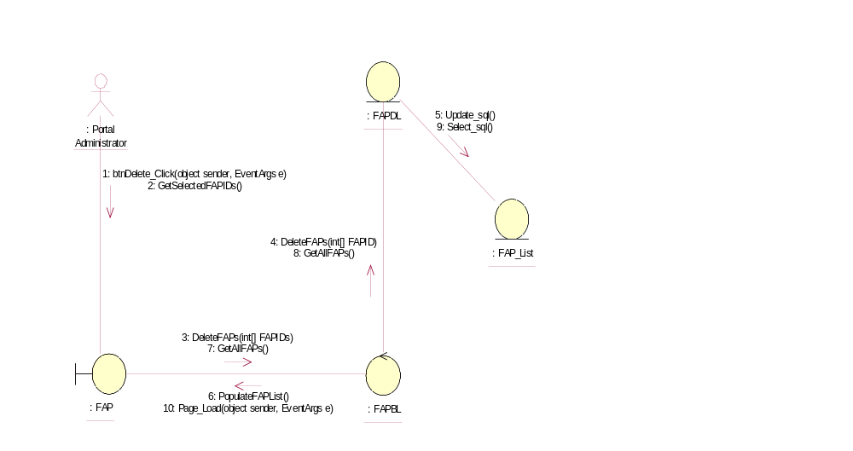

Sequence Diagram for Delete Fap
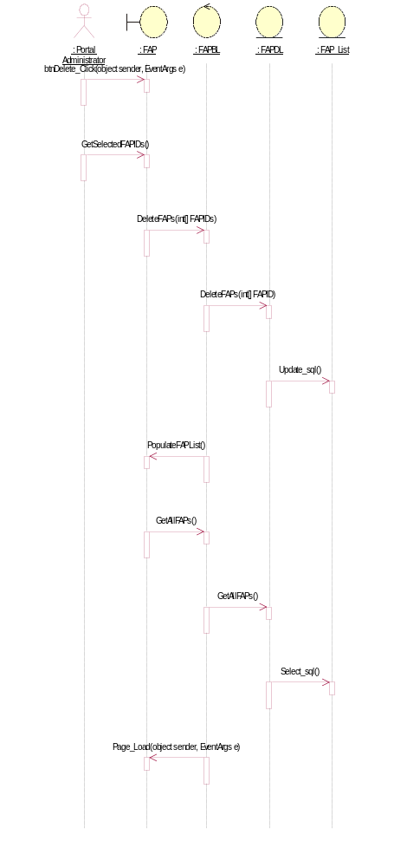

Participating Objects
: FAP

: FAP_List

: FAPBL

: FAPDL

: Portal Administrator

Class Diagrams

Class Diagram for Delete Fap
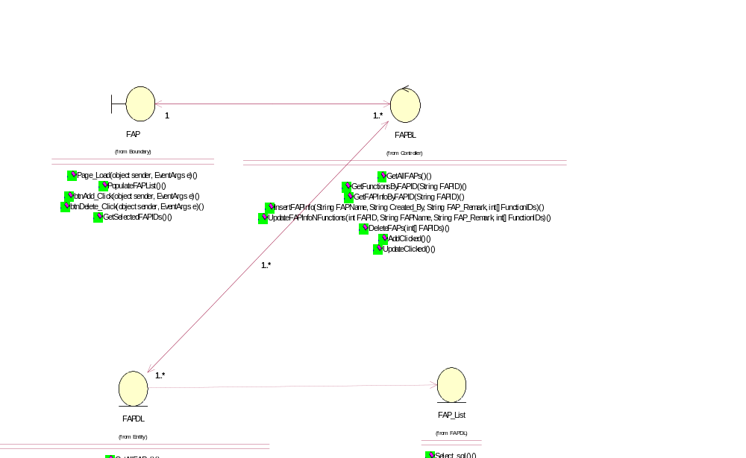

Derived Requirements
[enter the derived requirements here]

